Quote Summary

This document summarizes quotes for medical-grade incinerator systems from multiple companies. Emails correspondence took place in September 2018. It was determined that the cost of these devices is greater than the reasonable budget for a hospital in a low-income area.

# GEIWorks Helios 0.3: Solid Waste Incinerator

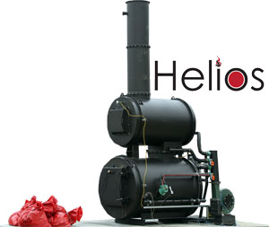

* A document was provided which summarizes emissions. Item number 550-V03

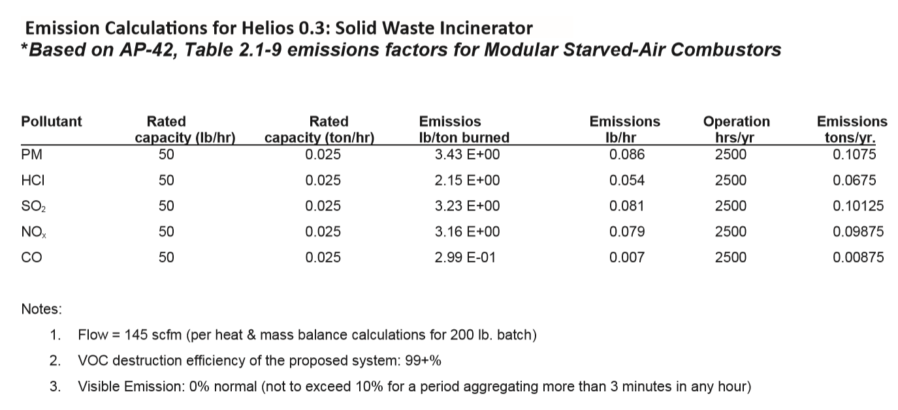

* Starved/controlled air, 2 chamber, 2nd chamber is “cyclonic secondary combustion chamber”
* 0.3 MMBtu/hr waste combustion
  + A BTU is the amount of heat required to increase the temperature of a pint of water (16 oz) by one degree Fahrenheit. 3412 BTU = 1 kWh, 1 BTU = 1055.56 joules
  + A wooden kitchen match produces roughly 1 BTU.
  + MBTU = MMBTU = one million BTU
* Primary chamber details:
  + 13.5 cu. Ft. chamber volume
  + Hearth area of 5 sq ft
  + Brochure lists materials for insulation
* Secondary chamber
  + 13.5 cu ft
* Features: Siemens PLC with touch screen interface. All sorts of temperature control, burner interface, system status/alarms, hydraulic system control for optional loading system. They include schematics and 3D models
* Cost: $43,137.50

# Inciner8

* This group provided suggestions for a few different models:
  + I8-10s - 20kgs per hour - Capacity 0.1m3 - $6,200.00
  + I8-M15 - 25kgs per hour / Capacity 0.13m3 - $15,000.00
  + I8-M20 - 30kgs per hour / Capacity 0.18m3 - $25,500.00
  + I8-M40 - 35kgs per hour / Capacity 0.36m3 - $28,900.00
* Can ship 1 week from date of payment
* Optional parts:
  + 650 Liter diesel fuel tank and piping for $2,900
  + One year spare parts: $2,100
  + Delivery to sea port: TBD depending on port. Probably expensive.

This model has a burn rate up to 20kg per hour and a compact footprint, gases are re-burned in the secondary chamber to eradicate smoke, odours and harmful emissions providing a clean incineration process. Incineration will allow waste to be destroyed at the source, removing the risk of cross-contamination and preventing potential spread of diseases or other environmental harm caused by chemical leakages.

* Features:
  + IP65 weatherproof
  + 316 stainless thermocouples
  + Independent secondary/ primary control

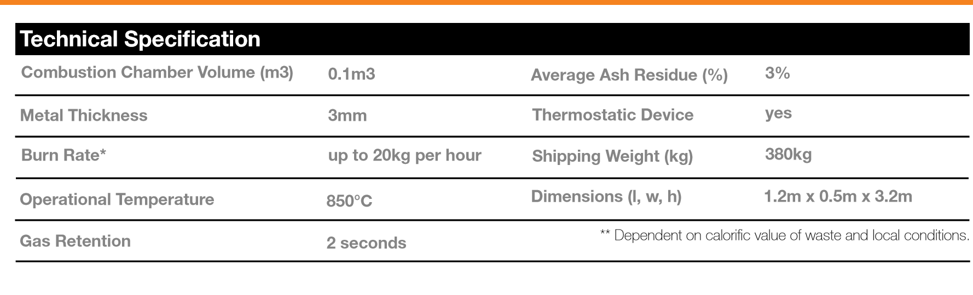

They suggest a sheltered area. Other options are containerized, or trailer mounted. These can be provided by the manufacturer.

Containers supplied are ISO 6346 certified (a shipping container standard that lists serial number, owner, country code, and size)

The brochure lists all the CE conformity. Good list of things we need to consider

BS EN 746-2:1997

Low voltage directive 73/23/EEC

EMC compatibility regulation 89/336/EEC

Machinery Directive 2006/42/EC (including amendment)

EC No 1005/2009 on substances that deplete ozone layer

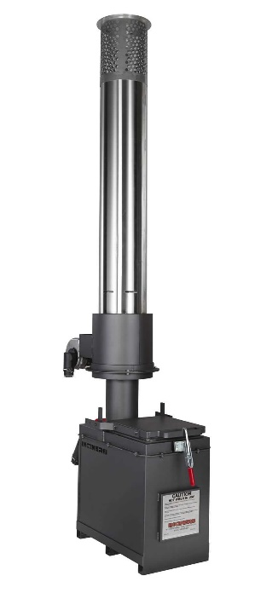

# Elastec MediBurn

$32,000-34,000

They gave a long list of all of their clients

1000 C, 50-75 lbs (20 – 30 kg) of material per hour. Incinerates medical waste to animal remains

Dual chamber

Electronic controls

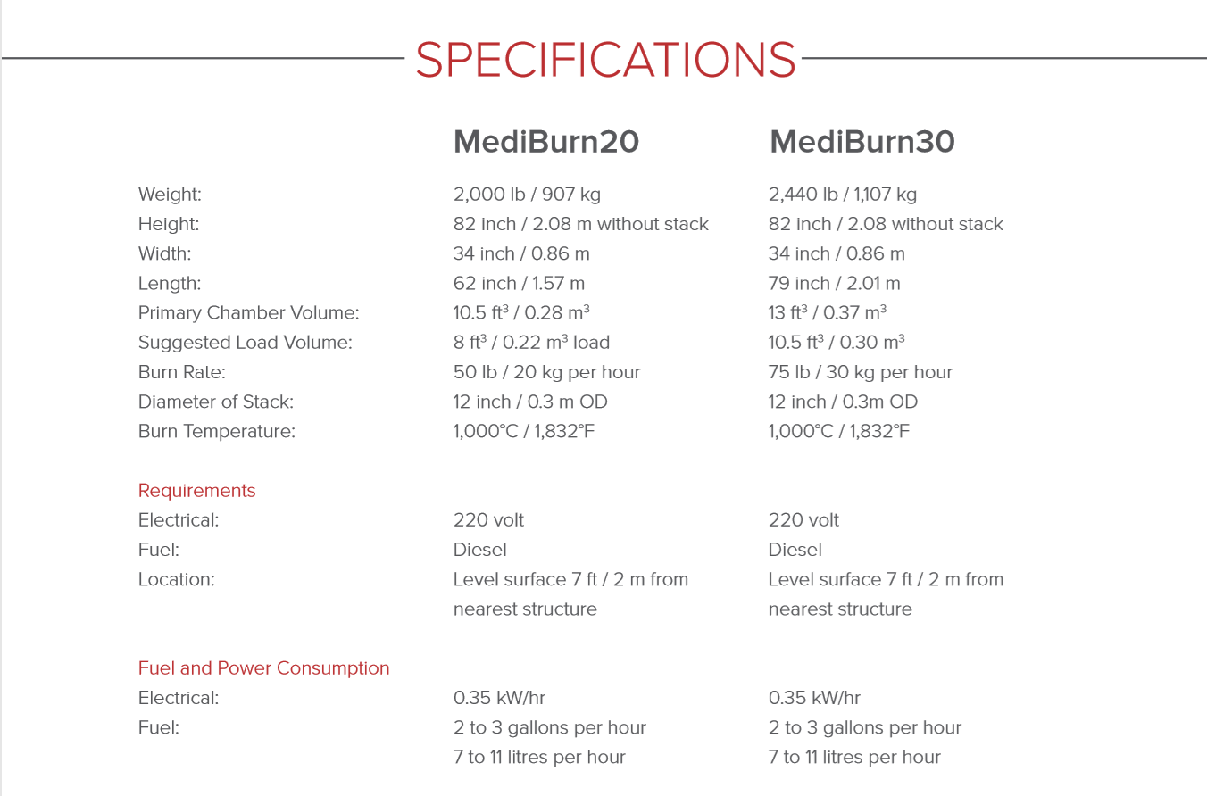

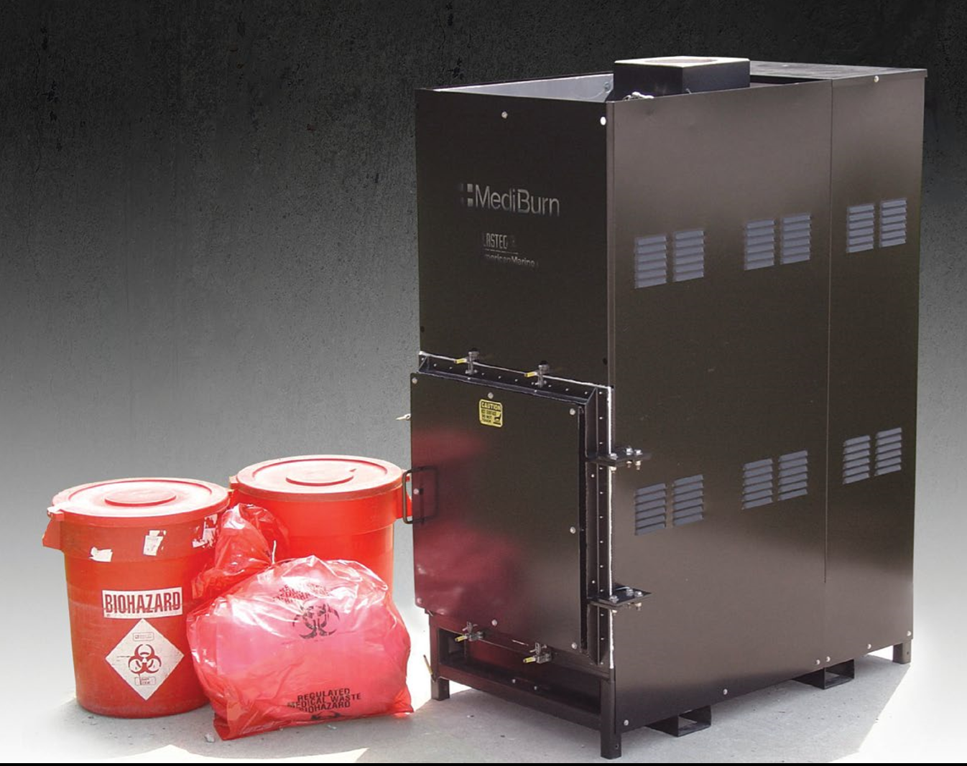

# IncineratorGuys

They offered a few different models:

The A- is Agricultural, C- is unclear, and P- is much more robust secondary/filtration system.

|  |  |  |  |
| --- | --- | --- | --- |
|  | Without secondary | With secondary |  |
| A-200 | 8,200 | 9,950 |  |
| A-400 | 10,995 | 11,400 |  |
| C6-200 | 23,950-27,950 | Depends on fuel/electrical |  |
| C12-400 | 26,9950 – 29,950 | “” |  |
| **P-16** | **35,950 – 39,950** | **This is the medical-specific model** |  |

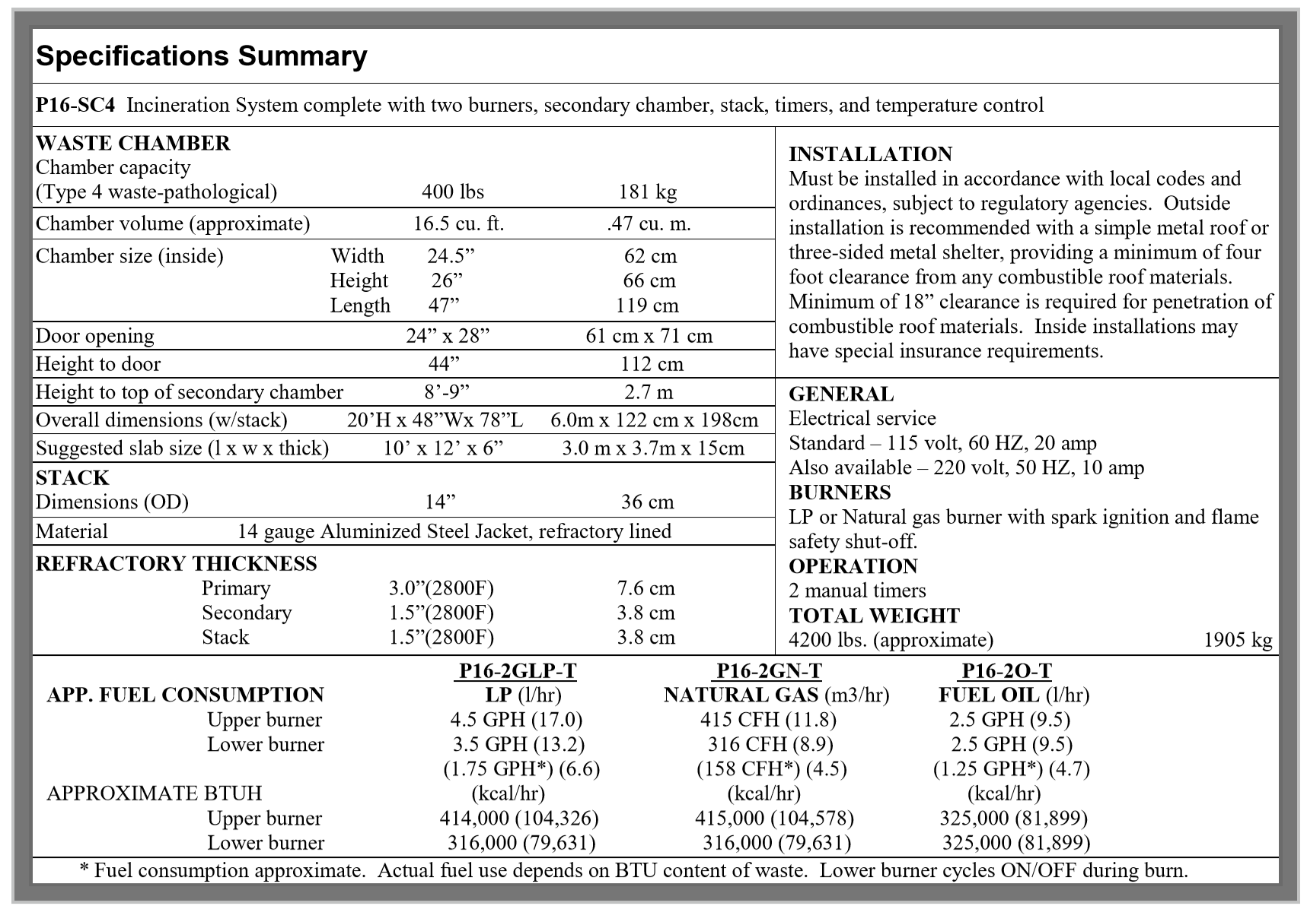

Allows for multiple fuel options including “fuel oil, LP or natural gas”

# Summary Table

|  |  |  |  |  |  |  |  |
| --- | --- | --- | --- | --- | --- | --- | --- |
|  | Burn capacity (lb/hr) | Style | Electricity required? | Emissions | Fuel source | Fuel Capacity | Price |
| GEIWorks Helios 0.3 | 0.3 MBTU/hr, 30-50 lbs processing capacity average | Starved air 2 chamber | Yes. 120 VAC, 25 amp | Good (I think?) | Diesel | 25 gallons | 43,137.50 |
| Inciner8 I8-10s |  | Starved air 2 chamber |  |  |  |  |  |
|  |  |  |  |  |  |  |  |
| MediBurn20 (smaller model) | 20kg/hr,  0.22 m^3 load | Starved air 2 chamber | 0.35 kW/hr, 220V |  | Diesel | 2-3 gallons/hr | $32,000-34,000 |
| IncineratorGuys |  |  |  |  |  |  | $35,950-39,950 |